Welcome To
Trinity Lutheran Church
Lutheran Church—Missouri Synod
A Stephen Ministry Congregation

1354 South Otsego Avenue
Gaylord, Michigan 49735
Church Phone: (989) 732-4816

Church Email: secretary@trinitygaylord.com
www.trinitygaylord.com

Office Hours: Monday through Friday 9am – 1pm

OUR PURPOSE
…is to LOVE GOD, LOVE OTHERS, AND SERVE THE WORLD by worshiping the Lord Jesus, bringing our members into Christ-like maturity, and equipping them through Word and Sacrament for their mission and ministry. We go heart to heart into the world with Jesus, sharing His love, caring for one another, praying, and bringing the lost into a relationship with Christ, by the working of the Holy Spirit.

July 24, 2022
Seventh Sunday after Pentecost
Preacher: Rev. Ken Bernthal

ABOUT OUR WORSHIP
We welcome all who gather here today! We are blessed to celebrate together the mercy, grace, and love we have from God through the death and resurrection of our Lord Jesus Christ.

Children: Families with children are very welcome here. Having children in church is important so they can begin to learn about their faith in Jesus, and it’s good for the whole congregation to see. Please feel comfortable keeping “squirmy” kids in the service. This is where they belong, too!

Pew Cards: Guests and Members, please fill out the Guest/Member card located on the back of the pew in front of you and pass it to the end of the aisle. If you forget you can put it in the offering plate on your way out.

If standing is difficult: Please feel free to remain seated during any portion of the service. Please let an Elder or Usher know if you need communion in your pew seat.

About our celebration of Holy Communion: We celebrate the Lord’s Supper in the confession and glad confidence that, as he says, our Lord gives into our mouths not only bread and wine but his very body and blood to eat and to drink for the forgiveness of sins and to strengthen our union with him and with one another. Our Lord invites to his table those who trust his words, repent of all sin, and set aside any refusal to forgive and love as he forgives and loves us, that they may show forth his death until he comes.

Because those who eat and drink our Lord’s body and blood contrary to that which is stated above do so to their great harm, and also because Holy Communion is a confession of the faith which is confessed at this altar. Anyone who is not yet instructed, in doubt, or who hold a confession differing from that of the Lutheran Church—Missouri Synod, and yet desire to receive the sacrament, are asked first to speak with Pastor. Those not communing are still invited to come forward for a blessing from Pastor, and you may indicate this by crossing your arms over your chest.
TTTTTT
GREETING

P Peace be with you.
C And also with you.

T ORDER OF SERVICE T
(The liturgy is from Divine Service Setting four LSB pg. 203ff)

OPENING HYMN
Great Is Thy Faithfulness LSB 809
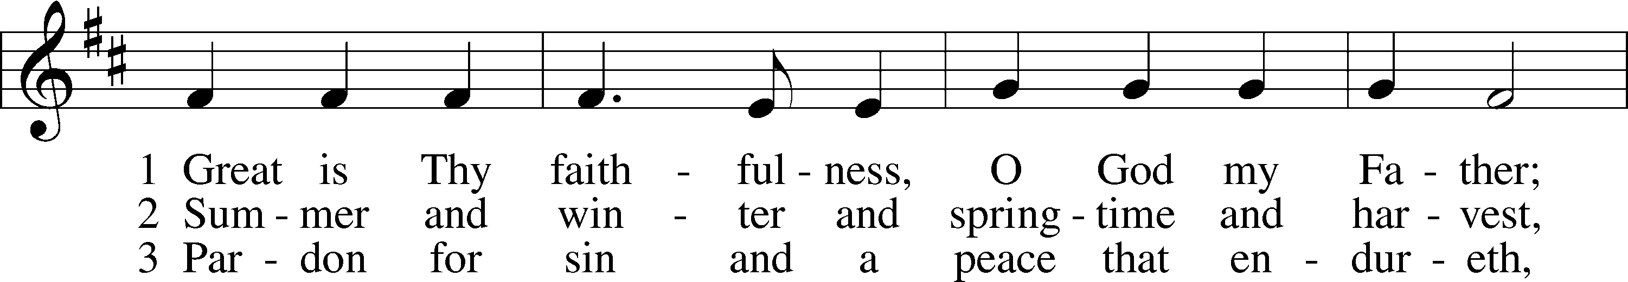
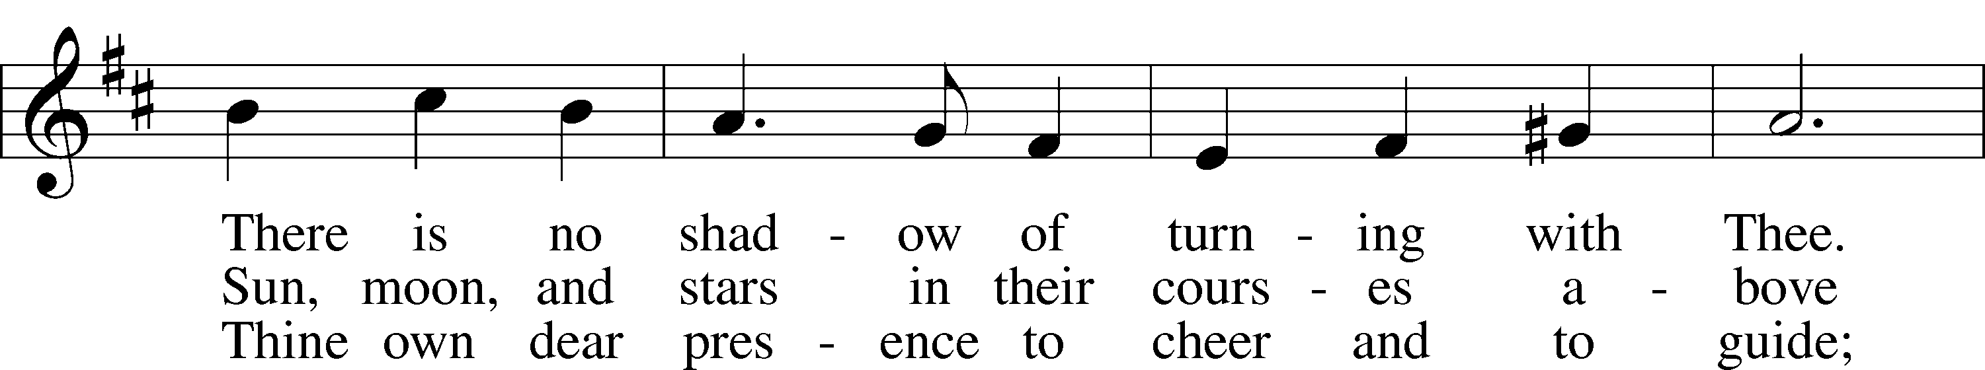
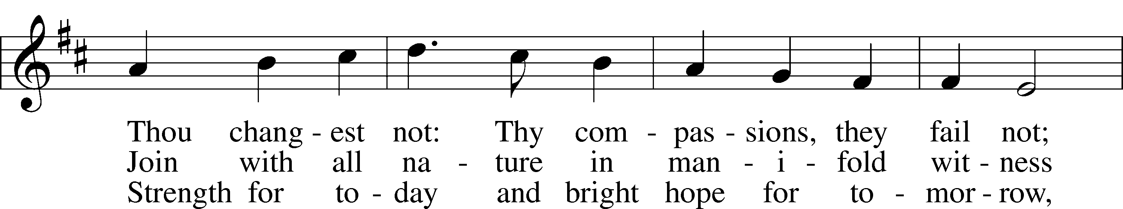
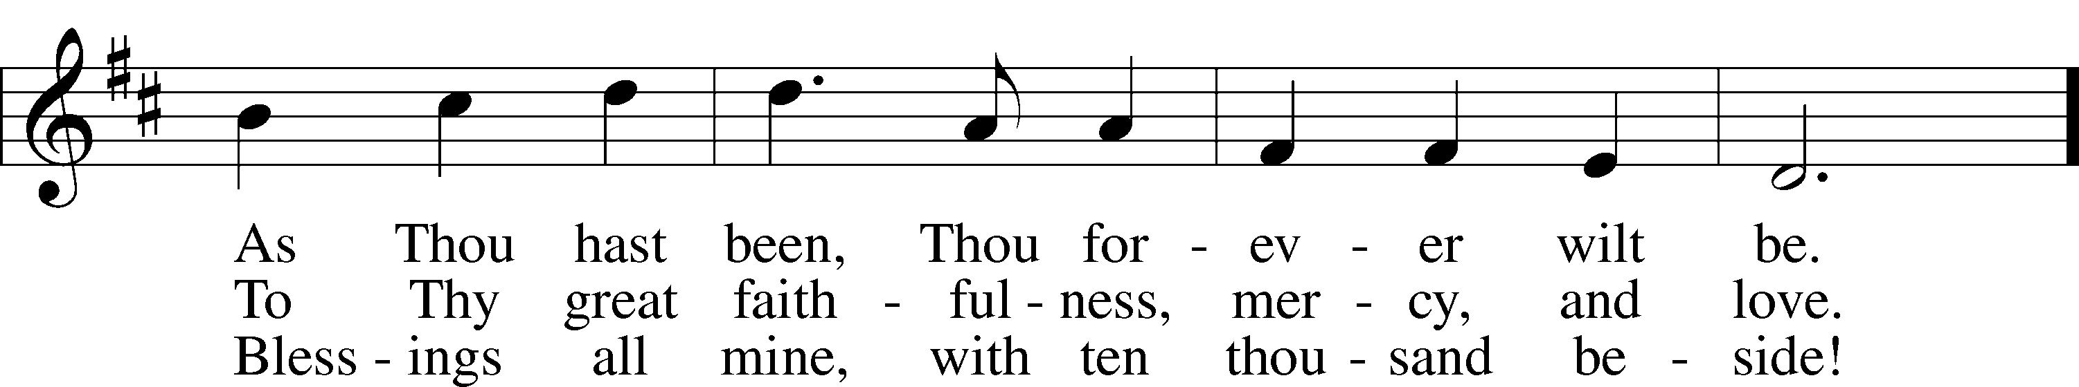
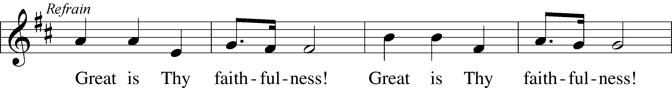
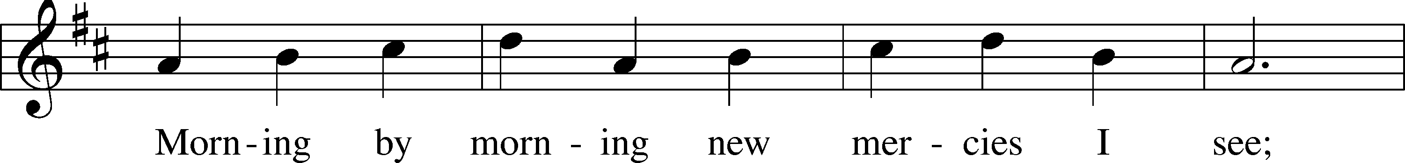
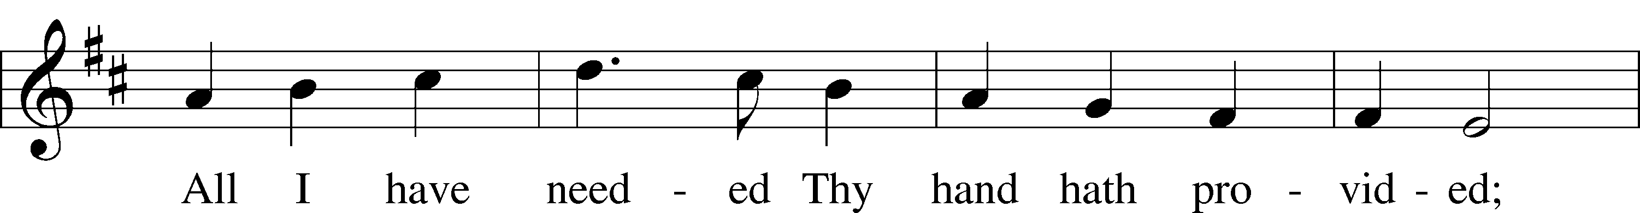
Continued on next page

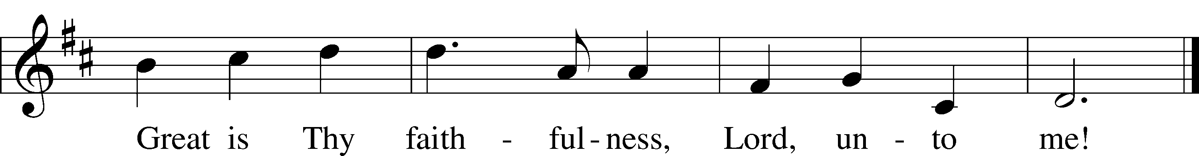
Text: Thomas O. Chisholm, 1866–1960
Tune: William M. Runyan, 1870–1957
Text: Public domain
Tune: Public domain

Please stand as able
CONFESSION and ABSOLUTION
The sign of the cross may be made by all in remembrance of their Baptism.

P In the name of the Father and of the T Son and of the Holy Spirit.
C Amen.
P Our help is in the name of the Lord,
C who made heaven and earth.
P If You, O Lord, kept a record of sins, O Lord, who could stand?
C But with You there is forgiveness; therefore, You are feared.
P Since we are gathered to hear God’s Word, call upon Him in prayer and praise, and receive the body and blood of our Lord Jesus Christ in the fellowship of this altar, let us first consider our unworthiness and confess before God and one another that we have sinned in thought, word, and deed, and that we cannot free ourselves from our sinful condition. Together as His people let us take refuge in the infinite mercy of God, our heavenly Father, seeking His grace for the sake of Christ, and saying: God, be merciful to me, a sinner.
C Almighty God, have mercy upon us, forgive us our sins, and lead us to everlasting life. Amen.
P Almighty God in His mercy has given His Son to die for you and for His sake forgives you all your sins. As a called and ordained servant of Christ, and by His authority, I therefore forgive you all your sins in the name of the Father and of the T Son and of the Holy Spirit.
C Amen.

SERVICE OF THE WORD
INTROIT Psalm 119:145–149; antiphon: Psalm 50:15
P Call upon me in the day of trouble;
I will deliver you, and you shall glorify me.
C With my whole heart I cry; answer me, O Lord!
I will keep your statutes.
P I call to you; save me,
that I may observe your testimonies.
C I rise before dawn and cry for help;
I hope in your words.
P My eyes are awake before the watches of the night,
that I may meditate on your promise.
C Hear my voice according to your steadfast love;
O Lord, according to your justice give me life.
Glory be to the Father and to the Son
and to the Holy Spirit;
as it was in the beginning,
is now, and will be forever. Amen.
P Call upon me in the day of trouble;
I will deliver you, and you shall glorify me.

KYRIE LSB 204
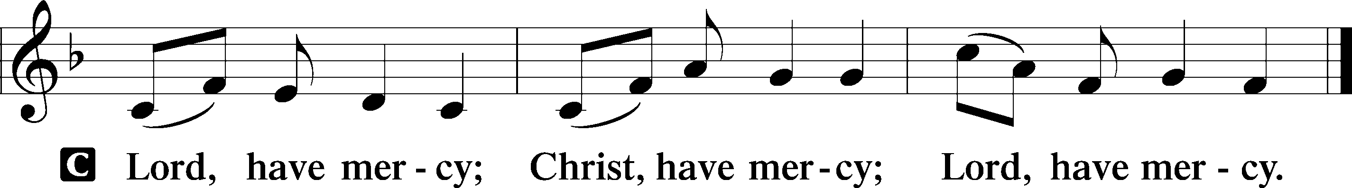

HYMN OF PRAISE
GLORIA IN EXCELSIS LSB 204
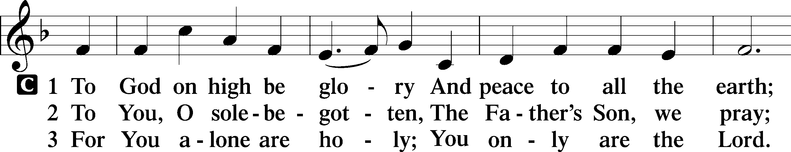
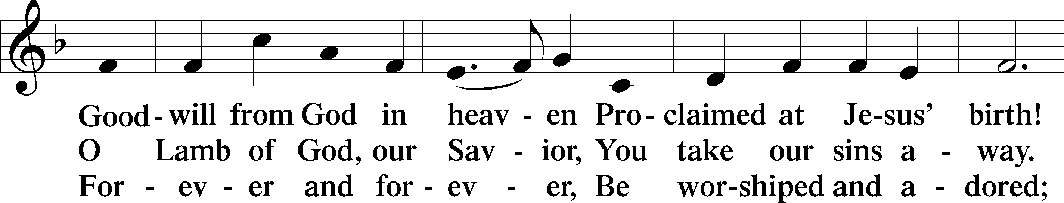
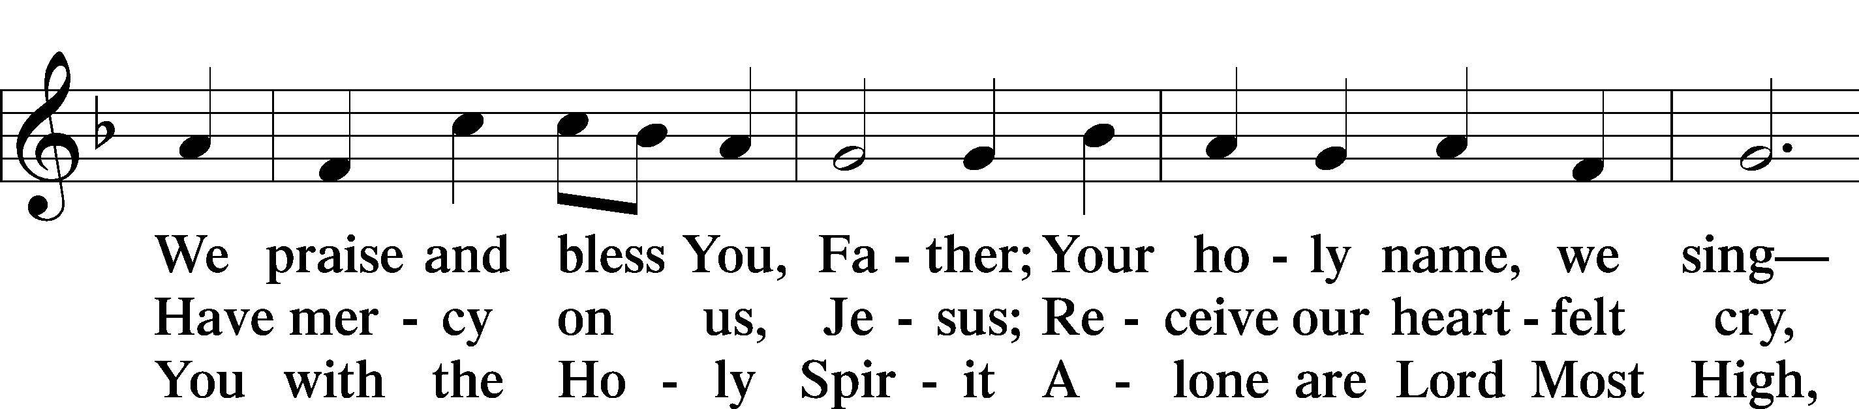
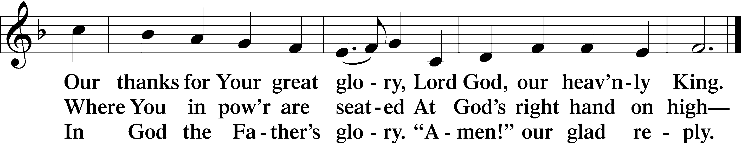
Text: Stephen P. St

SALUTATION AND COLLECT OF THE DAY
P The Lord be with you.
C And also with you.

P Let us pray.
O Lord, let Your merciful ears be attentive to the prayers of Your servants, and by Your Word and Spirit teach us how to pray that our petitions may be pleasing before You; through Jesus Christ, Your Son, our Lord, who lives and reigns with You and the Holy Spirit, one God, now and forever.
C Amen.

Please be seated
OLD TESTAMENT Genesis 18:20–33
²⁰Then the Lord said, “Because the outcry against Sodom and Gomorrah is great and their sin is very grave, ²¹I will go down to see whether they have done altogether according to the outcry that has come to me. And if not, I will know.”
²²So the men turned from there and went toward Sodom, but Abraham still stood before the Lord. ²³Then Abraham drew near and said, “Will you indeed sweep away the righteous with the wicked? ²⁴Suppose there are fifty righteous within the city. Will you then sweep away the place and not spare it for the fifty righteous who are in it? ²⁵Far be it from you to do such a thing, to put the righteous to death with the wicked, so that the righteous fare as the wicked! Far be that from you! Shall not the Judge of all the earth do what is just?” ²⁶And the Lord said, “If I find at Sodom fifty righteous in the city, I will spare the whole place for their sake.”
²⁷Abraham answered and said, “Behold, I have undertaken to speak to the Lord, I who am but dust and ashes. ²⁸Suppose five of the fifty righteous are lacking. Will you destroy the whole city for lack of five?” And he said, “I will not destroy it if I find forty-five there.” ²⁹Again he spoke to him and said, “Suppose forty are found there.” He answered, “For the sake of forty I will not do it.” ³⁰Then he said, “Oh let not the Lord be angry, and I will speak. Suppose thirty are found there.” He answered, “I will not do it, if I find thirty there.” ³¹He said, “Behold, I have undertaken to speak to the Lord. Suppose twenty are found there.” He answered, “For the sake of twenty I will not destroy it.” ³²Then he said, “Oh let not the Lord be angry, and I will speak again but this once. Suppose ten are found there.” He answered, “For the sake of ten I will not destroy it.”
³³And the Lord went his way, when he had finished speaking to Abraham, and Abraham returned to his place.

P This is the Word of the Lord.
C Thanks be to God.

EPISTLE Colossians 2:6–19
⁶Therefore, as you received Christ Jesus the Lord, so walk in him, ⁷rooted and built up in him and established in the faith, just as you were taught, abounding in thanksgiving.
⁸See to it that no one takes you captive by philosophy and empty deceit, according to human tradition, according to the elemental spirits of the world, and not according to Christ. ⁹For in him the whole fullness of deity dwells bodily, ¹⁰and you have been filled in him, who is the head of all rule and authority. ¹¹In him also you were circumcised with a circumcision made without hands, by putting off the body of the flesh, by the circumcision of Christ, ¹²having been buried with him in baptism, in which you were also raised with him through faith in the powerful working of God, who raised him from the dead. ¹³And you, who were dead in your trespasses and the uncircumcision of your flesh, God made alive together with him, having forgiven us all our trespasses, ¹⁴by canceling the record of debt that stood against us with its legal demands. This he set aside, nailing it to the cross. ¹⁵He disarmed the rulers and authorities and put them to open shame, by triumphing over them in him.
¹⁶Therefore let no one pass judgment on you in questions of food and drink, or with regard to a festival or a new moon or a Sabbath. ¹⁷These are a shadow of the things to come, but the substance belongs to Christ. ¹⁸Let no one disqualify you, insisting on asceticism and worship of angels, going on in detail about visions, puffed up without
reason by his sensuous mind, ¹⁹and not holding fast to the Head, from whom the whole body, nourished and knit together through its joints and ligaments, grows with a growth that is from God.

P This is the Word of the Lord.
C Thanks be to God.

Please stand as able

ALLELUIA AND VERSE
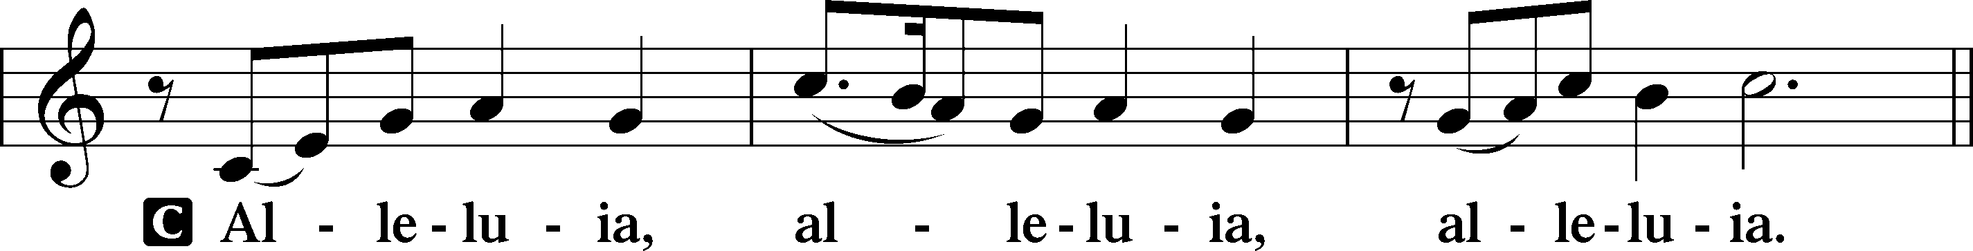
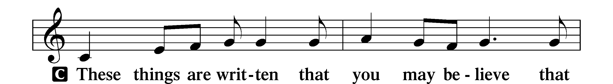

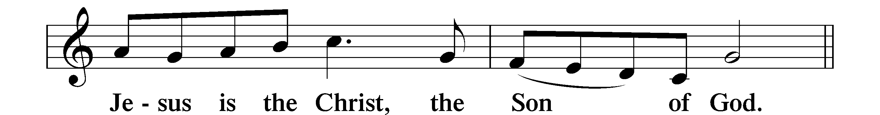
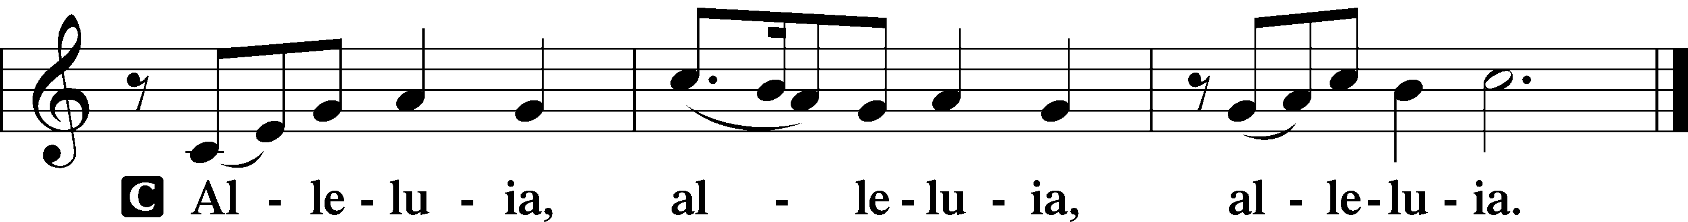

HOLY GOSPEL Luke 11:1–13
P The Holy Gospel according to St. Luke, the eleventh chapter.
C Glory to You, O Lord.

¹Now Jesus was praying in a certain place, and when he finished, one of his disciples said to him, “Lord, teach us to pray, as John taught his disciples.” ²And he said to them, “When you pray, say:
“Father, hallowed be your name.
Your kingdom come.
³Give us each day our daily bread,
⁴and forgive us our sins,
for we ourselves forgive everyone who is indebted to us.
And lead us not into temptation.”
⁵And he said to them, “Which of you who has a friend will go to him at midnight and say to him, ‘Friend, lend me three loaves, ⁶for a friend of mine has arrived on a journey, and I have nothing to set before him’; ⁷and he will answer from within, ‘Do not bother me; the door is now shut, and my children are with me in bed. I cannot get up and give you anything’? ⁸I tell you, though he will not get up and give him anything because he is his friend, yet because of his impudence he will rise and give him whatever he needs. ⁹And I tell you, ask, and it will be given to you; seek, and you will find; knock, and it will be opened to you. ¹⁰For everyone who asks receives, and the one who seeks finds, and to the one who knocks it will be opened. ¹¹What father among you, if his son asks for a fish, will instead of a fish give him a serpent; ¹²or if he asks for an egg, will give him a scorpion? ¹³If you then, who are evil, know how to give good gifts to your children, how much more will the heavenly Father give the Holy Spirit to those who ask him!”

P This is the Gospel of the Lord.
C Praise to You, O Christ.

NICENE CREED
C I believe in one God,
the Father Almighty,
maker of heaven and earth
and of all things visible and invisible.
And in one Lord Jesus Christ,
the only-begotten Son of God,
begotten of His Father before all worlds,
God of God, Light of Light,
very God of very God,
begotten, not made,
being of one substance with the Father,
by whom all things were made;
who for us men and for our salvation came down from heaven
and was incarnate by the Holy Spirit of the virgin Mary
and was made man;
and was crucified also for us under Pontius Pilate.
He suffered and was buried.
And the third day He rose again according to the Scriptures
and ascended into heaven
and sits at the right hand of the Father.
And He will come again with glory to judge both the living and the dead,
whose kingdom will have no end.
And I believe in the Holy Spirit,
the Lord and giver of life,
who proceeds from the Father and the Son,
who with the Father and the Son together is worshiped and glorified,
who spoke by the prophets.
And I believe in one holy Christian and apostolic Church,
I acknowledge one Baptism for the remission of sins,
and I look for the resurrection of the dead
and the life T of the world to come. Amen.

Please be seated

ALL GOD’S CHILDREN – TALK
SERMON HYMN
Come, My Soul, with Every Care LSB 779
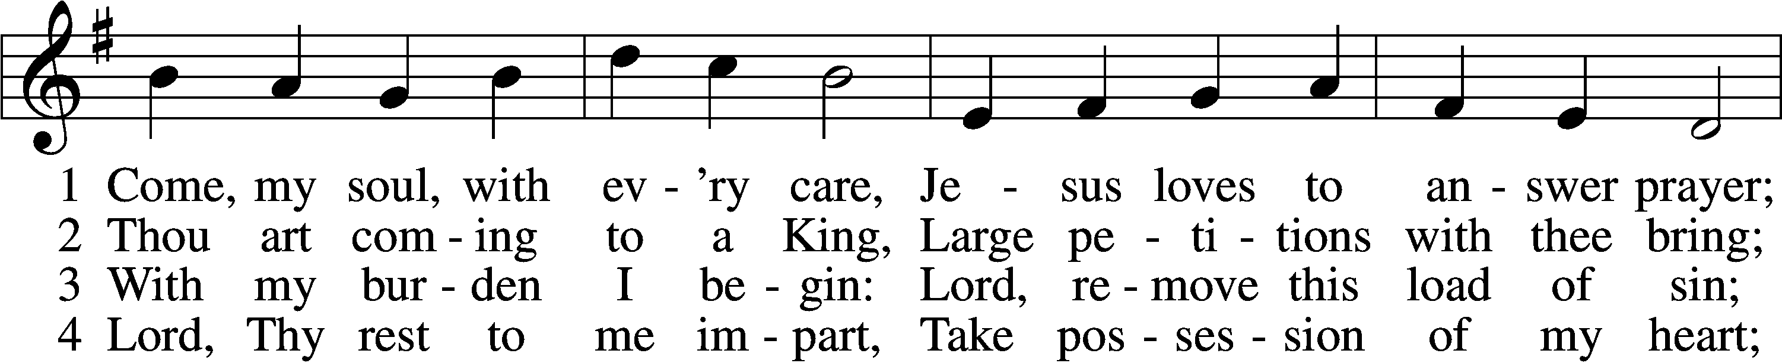
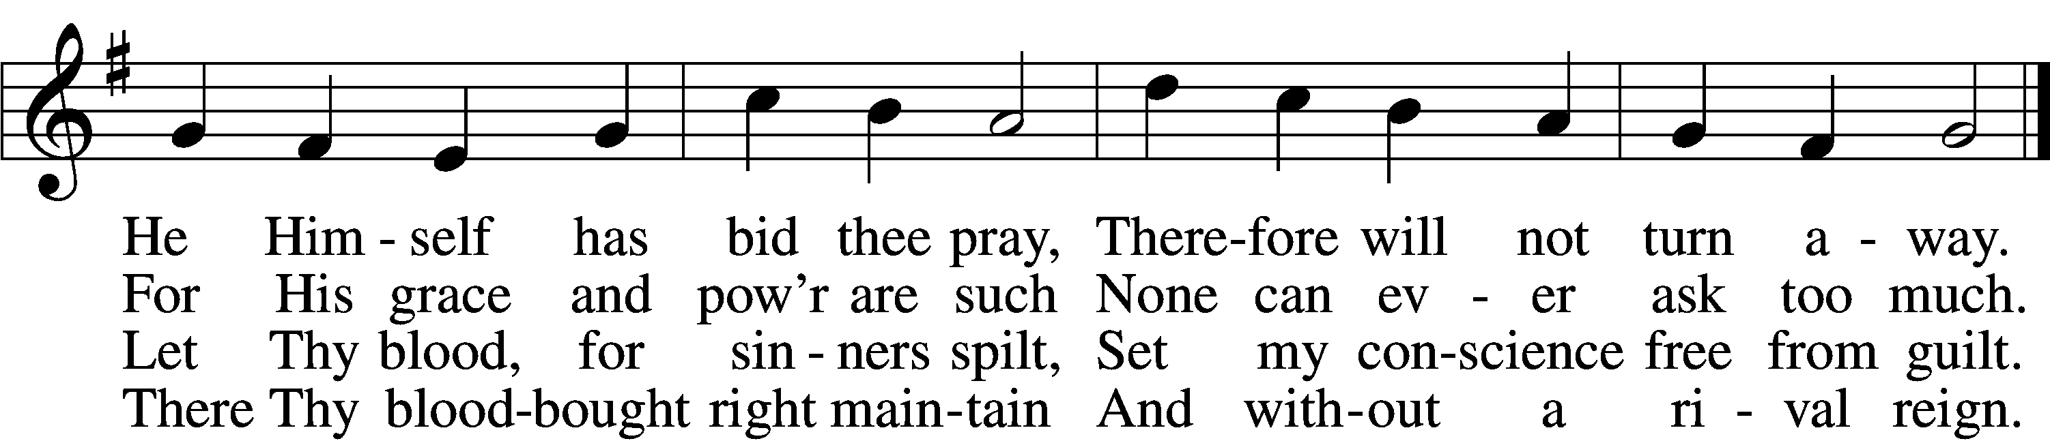

5 While I am a pilgrim here, 6 Show me what is mine to do;
Let Thy love my spirit cheer; Ev’ry hour my strength renew.
As my guide, my guard, my friend, Let me live a life of faith
Lead me to my journey’s end. Let me die Thy people’s death.
Text: John Newton, 1725–1807, alt. Tune: Justin H. Knecht, 1752–1817 Text and tune: Public domain

SERMON
Please stand as able
PRAYER of the CHURCH
After each Segment:
P Lord, in Your Mercy,
C Hear our Prayer.
After Final Segment:
P Hear us as we pray in His name and as He has taught us:
LORD’S PRAYER
C Our Father who art in heaven,
hallowed be Thy name,
Thy kingdom come,
Thy will be done on earth
as it is in heaven;
give us this day our daily bread;
and forgive us our trespasses
as we forgive those
who trespass against us;
and lead us not into temptation,
but deliver us from evil.
For Thine is the kingdom
and the power and the glory
forever and ever. Amen
SERVICE of the SACRAMENT

PREFACE LSB 208
P The Lord be with you.
C And also with you.
P Lift up your hearts.
C We lift them to the Lord.
P Let us give thanks to the Lord our God.
C It is right to give Him thanks and praise.
P It is truly good, right, and salutary that we should at all times and in all places give thanks to You, O Lord, holy Father, almighty and everlasting God, for the countless blessings You so freely bestow on us and all creation. Above all, we give thanks for Your boundless love shown to us when You sent Your only-begotten Son, Jesus Christ, into our flesh and laid on Him our sin, giving Him into death that we might not die eternally. Because He is now risen from the dead and lives and reigns to all eternity, all who believe in Him will overcome sin and death and will rise again to new life. Therefore with angels and archangels and with all the company of heaven we laud and magnify Your glorious name, evermore praising You and singing:

SANCTUS LSB 208
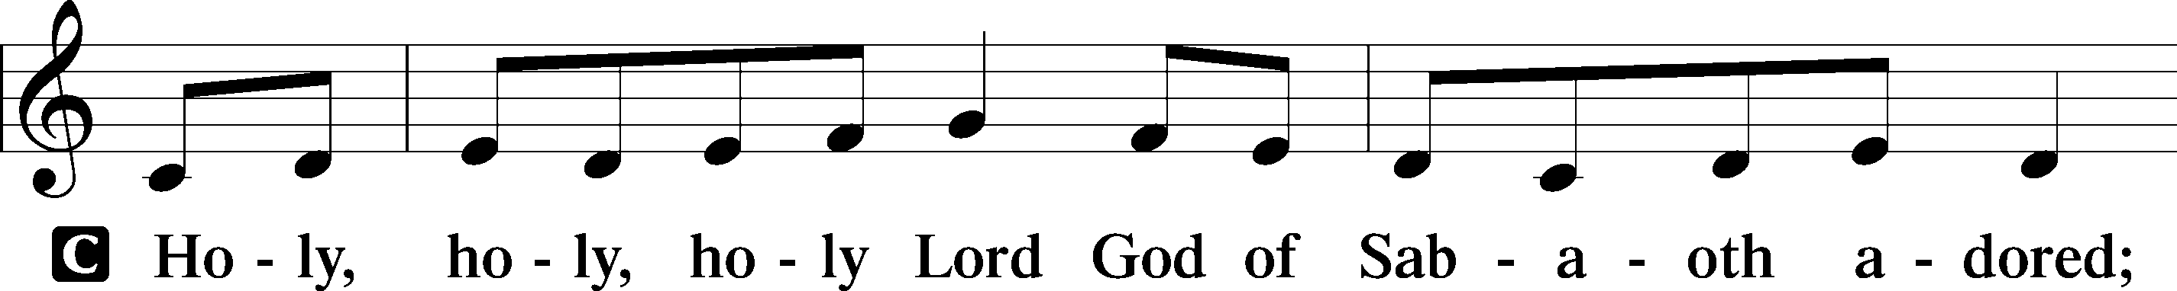
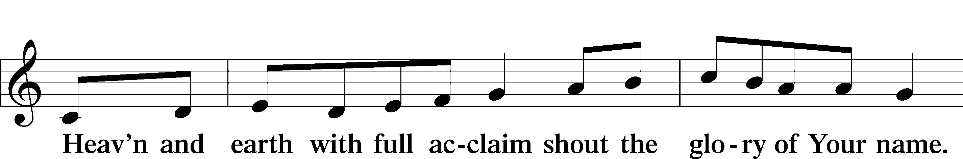
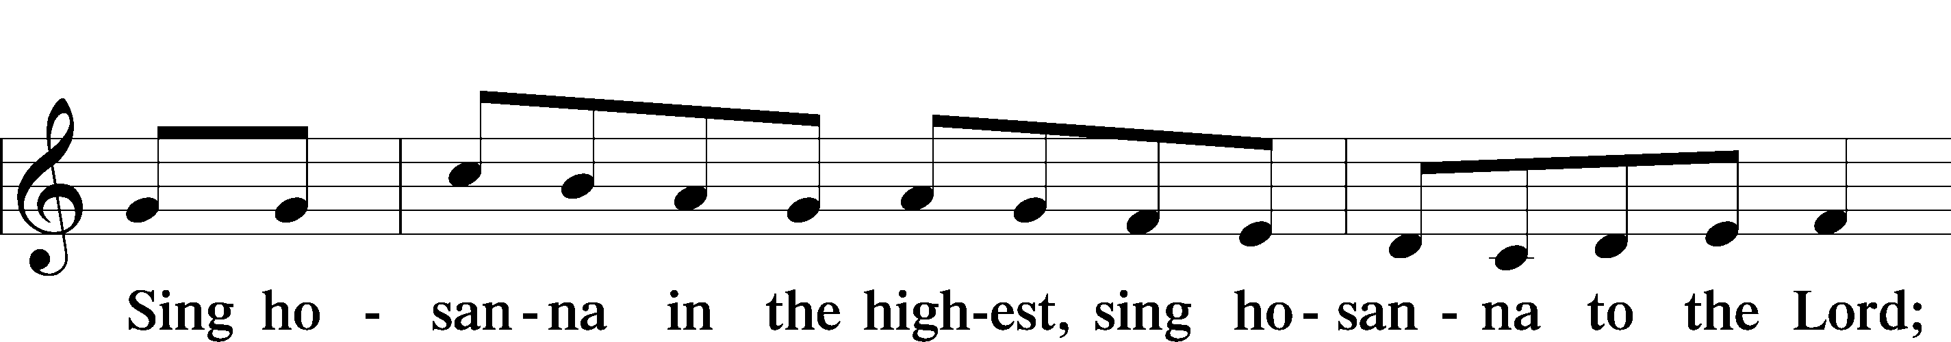

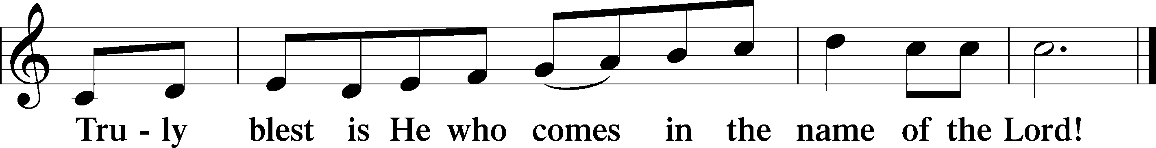
PRAYER OF THANKSGIVING
P Blessed are You, O Lord our God, king of all creation, for You have had mercy on us and given Your only-begotten Son that whoever believes in Him should not perish but have eternal life.
In Your righteous judgment You condemned the sin of Adam and Eve, who ate the forbidden fruit, and You justly barred them and all their children from the tree of life. Yet, in Your great mercy, You promised salvation by a second Adam, Your Son, Jesus Christ, our Lord, and made His cross a life-giving tree for all who trust in Him.
We give You thanks for the redemption You have prepared for us through Jesus Christ. Grant us Your Holy Spirit that we may faithfully eat and drink of the fruits of His cross and receive the blessings of forgiveness, life, and salvation that come to us in His body and blood.

THE WORDS OF OUR LORD
P Our Lord Jesus Christ, on the night when He was betrayed, took bread, and when He had given thanks, He broke it and gave it to the disciples and said: “Take, eat; this is My T body, which is given for you. This do in remembrance of Me.”
In the same way also, He took the cup after supper, and when He had given thanks, He gave it to them, saying: “Drink of it, all of you; this cup is the New Testament in My T blood, which is shed for you for the forgiveness of sins. This do, as often as you drink it, in remembrance of Me.”

PAX DOMINI
P The peace of the Lord be with you always.
C Amen.
AGNUS DEI
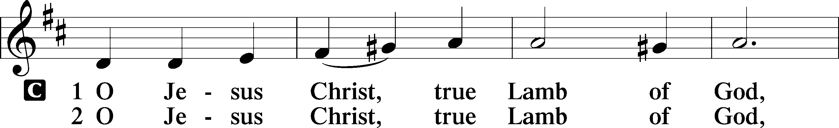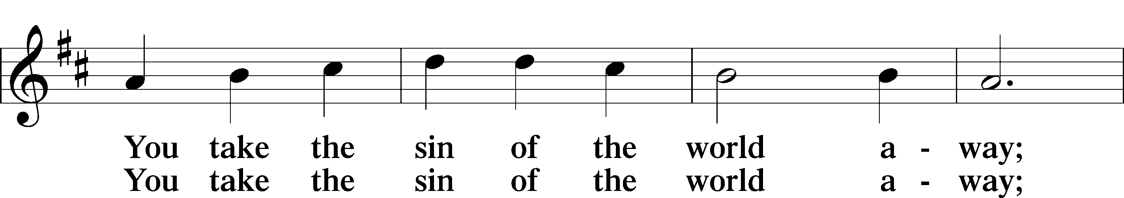
Continued on next page
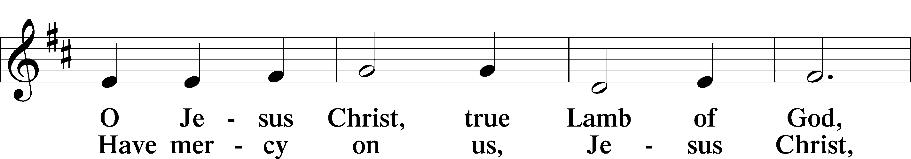
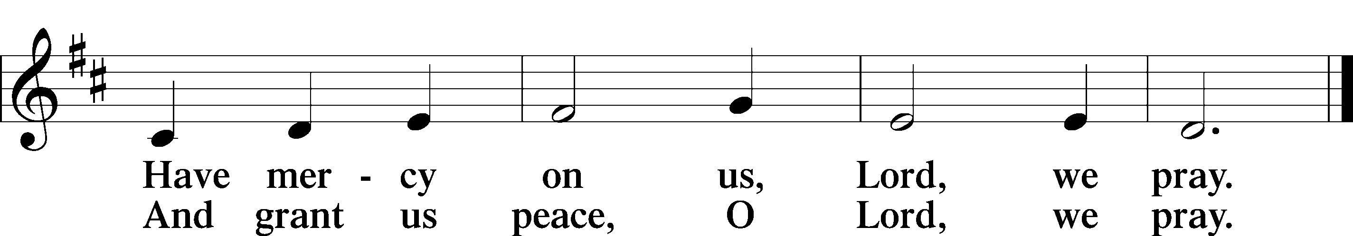

Please be seated
DISTRIBUTION
The pastor and those who assist him receive the body and blood of Christ first, then Communion will be served at the rail. Ushers will help direct you forward via the center aisle; please return to your seats via the side aisles. Gluten-free bread is available for those who need it, as is non-alcoholic grape juice. Simply request either when you come forward to receive Communion.
DISTRIBUTION HYMN
Jesus Comes Today with Healing LSB 620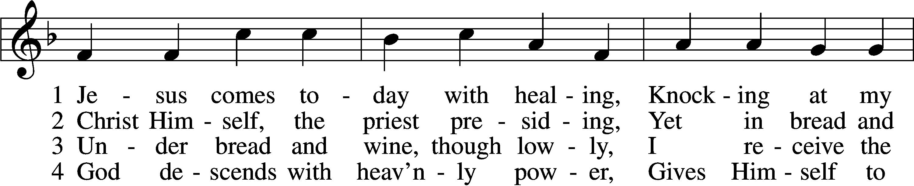
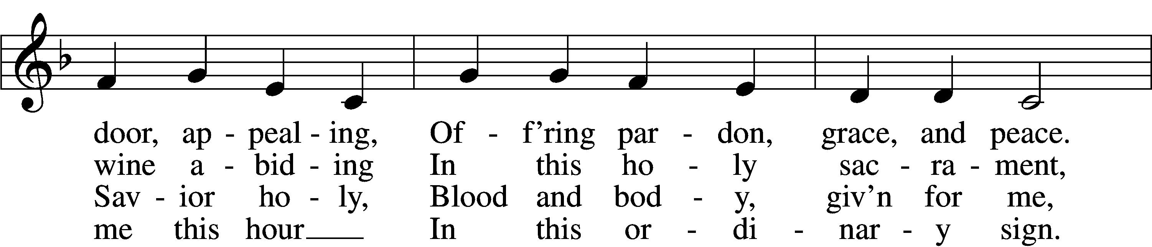
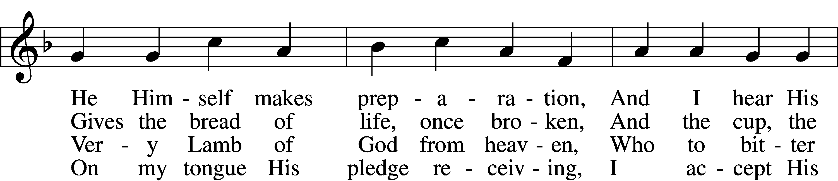

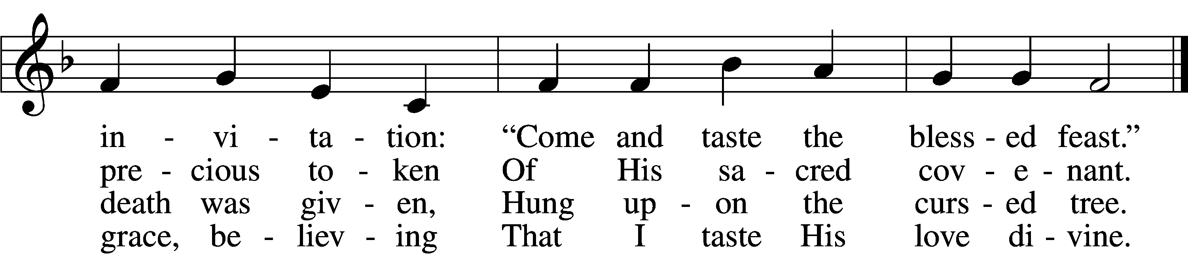

5 Let me praise God’s boundless favor,
Whose own feast of love I savor,
Bidden by His gracious call.
Wedding garments He provides me,
With a robe of white He hides me,
Fits me for the royal hall.
6 Now have I found consolation,
Comfort in my tribulation,
Balm to heal the troubled soul.
God, my shield from ev’ry terror,
Cleanses me from sin and error,
Makes my wounded spirit whole.
Text: Heinrich Puchta, 1808–58; tr. David W. Rogner, 1960
Tune: Johann Löhner, 1645–1705; adapt. Johann Balthasar König, 1691–1758
Text: © David W. Rogner. Used by permission: LSB Hymn License no. 110002537
Tune: Public domain

Please stand as able
NUNC DIMITTIS LSB 211
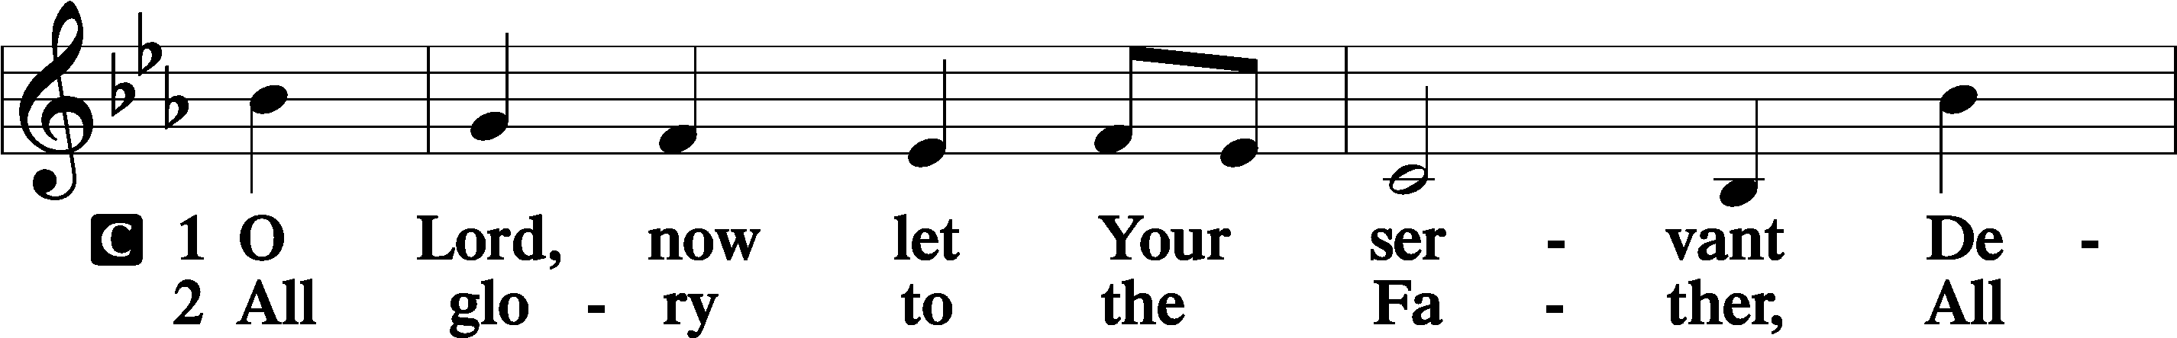
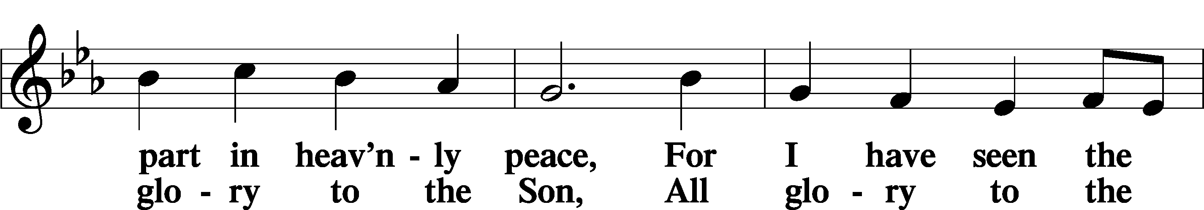
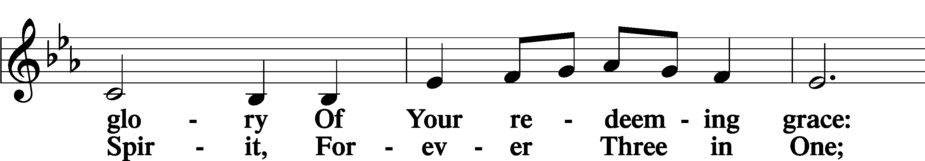
Continued on next page
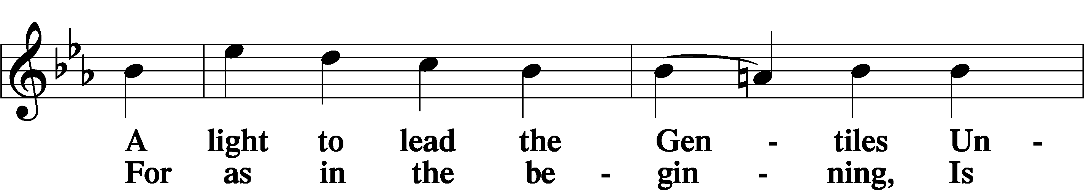
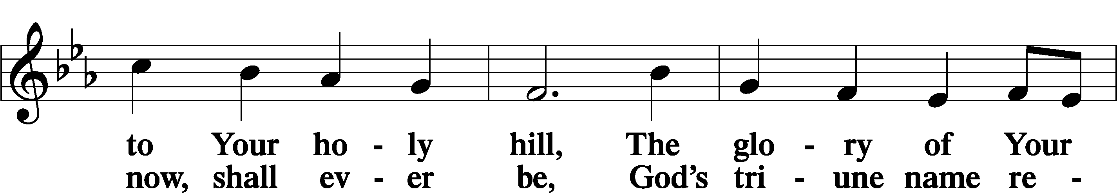
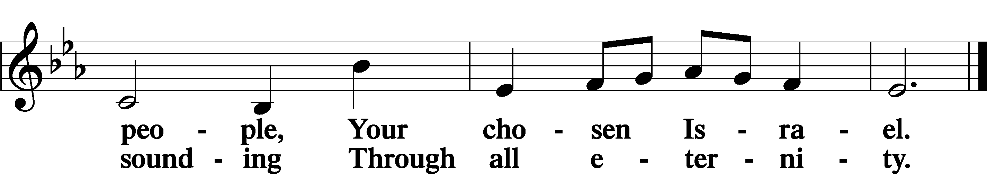

POST COMMUNION COLLECT
P Let us pray.
O God the Father, the fountain and source of all goodness, who in loving-kindness sent Your only-begotten Son into the flesh, we thank You that for His sake You have given us pardon and peace in this Sacrament, and we ask You not to forsake Your children but always to rule our hearts and minds by Your Holy Spirit that we may be enabled constantly to serve You; through Jesus Christ, Your Son, our Lord, who lives and reigns with You and the Holy Spirit, one God, now and forever.
C Amen.

BENEDICAMUS LSB 212
P Let us bless the Lord.
C Thanks be to God.
BENEDICTION
P The Lord bless you and keep you.
The Lord make His face shine on you and be gracious to you.
The Lord look upon you with favor and T give you peace.
C Amen.

Please be seated
CLOSING HYMN
What a Friend We Have in Jesus LSB 770
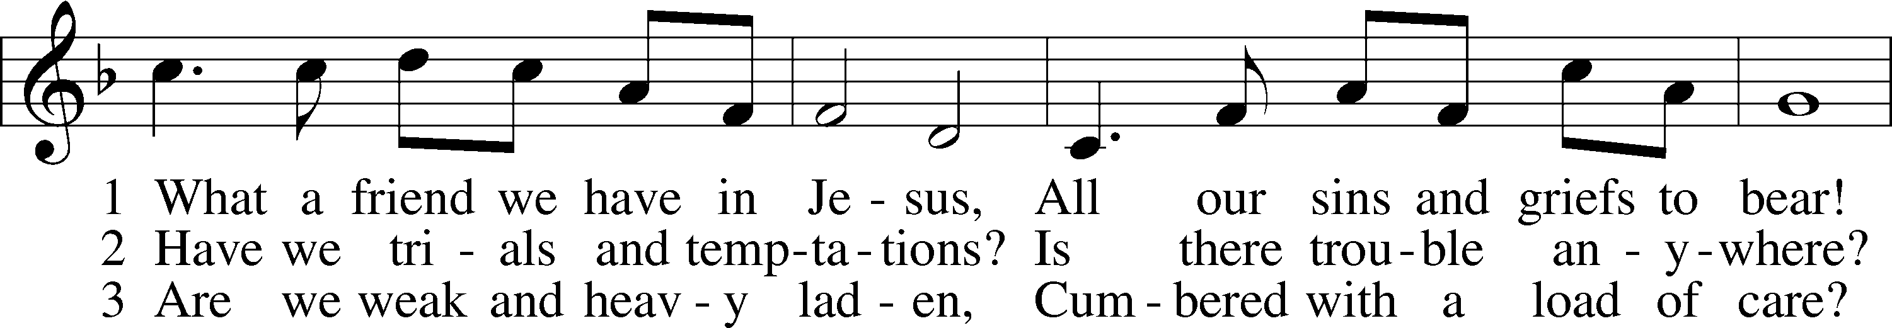
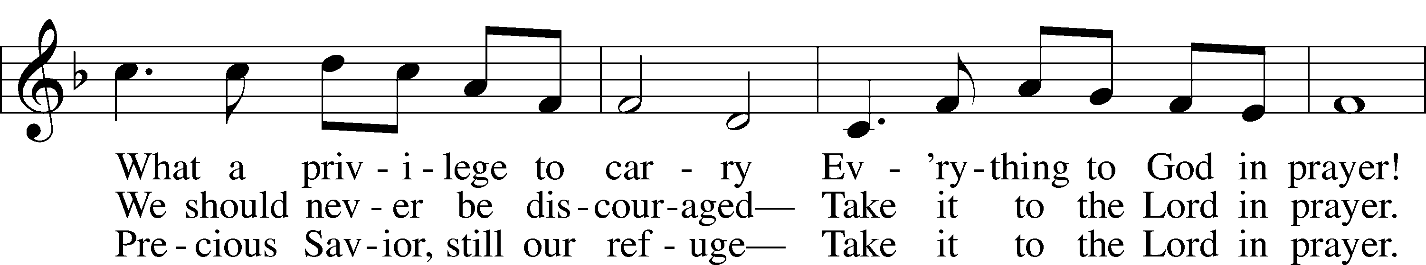
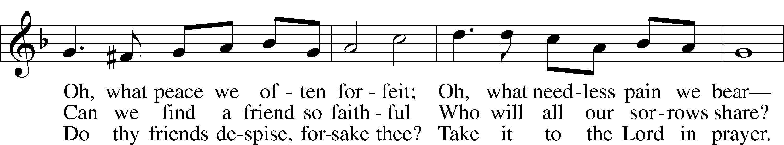
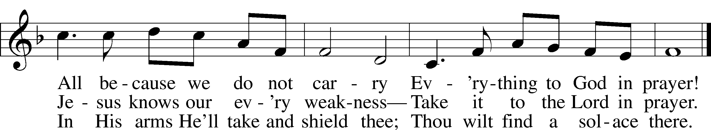

Text: Joseph M. Scriven, 1819–86
Tune: Charles C. Converse, 1832–1918
Text and tune: Public domain

ANNOUNCEMENTS and SENDING WORDS
P We go to live for Jesus!
C We go to share His love!

Acknowledgments
Unless otherwise indicated, Scripture quotations are from the ESV® Bible (The Holy Bible, English Standard Version®), copyright © 2001 by Crossway, a publishing ministry of Good News Publishers. Used by permission. All rights reserved. Created by Lutheran Service Builde

SERVING in GODS HOUSE TODAY
Pastor: Rev. Ken Bernthal
Elder: Tom Raithel
Ushers: Bill & Terry Stiles
Greeters: Tom & Terri Raithel
Coffee Servers: Church Picnic
Counters: Larry Whitney, Wendell Smith
Altar Care: Terri Raithel
Piano/Organist: Tom & Jean Beach
Children’s Talk: Nancy Ely
Post-Service Bible Study to resume in September
PRAYERS
Please contact the office with updates to the prayer list. People will remain on the prayer list for 4 weeks before being removed. If they need to remain on the list, please keep Elaine informed and of any updates. This will help us to have a more accurate list. Thanks for your cooperation.
Those who continue to grieve the passing of loved ones, The family of Vilma Ward
Those with upcoming surgery: Tom Beach
Those recovering from surgery: Tanner Beyers, Shirley Hildebrand, Marge Kunisch, and Jennifer Martin.
Those with health concerns: Tiffany Amsdill, Laurie Breen, Hope Buchinger,
Betsy Cook, Kay Gregg, Paul Kietzman, Hilda Koch, Ron Kwapis r, Eleanor Raether,
Beth Smith, Judi Stutzman, and Joann Whitney.
Those diagnosed with cancer: Leah Eicher, Rachel Frisch, Janice Knoellinger, Leslie Martin, Brian Morgan, Hope Osantowski, and John Stutzman.
Those under Hospice Home Care: Ken Williamson, Jim (Joann Whitney’s brother-in law).

BIRTHDAYS: ANNIVERSARIES;
7/24 Kyle Techel NONE
7/26 Rose Dittman
7/27 Brittany Beyers
7/27 Ken Mertz
7/27 Karen Schneider

MESSAGES

ALTAR FLOWERS today are given to the glory of God from Jim & Marge Kunisch in celebration of their anniversary.
MEMBER & GUEST CARDS: If you have not filled out a member/guest card, please take the time to fill one out and place it in the plate behind the back pews in our sanctuary.
WEDNESDAY MORNING BIBLE STUDY will resume in September.
GREETING CARDS If you are in need of some greeting cards, we carry an array of them in the cabinet on the wall next to the church office.. The cost of the cards is posted on the cabinet. The money collected from the cards goes to LWML to help support Missions.
LWML SUMMER POP-UP CRAFT SALES: LWML plans to have occasional mini craft sales this summer. With short notice we will set up a few canopies in the front yard and offer our crafts for sale, with the profits designated for missions, both locally and throughout the world. Dates have yet to be determined. So, crafters, please get thinking about what handmade items you can prepare in advance for us to sell. We welcome and appreciate your donations.

FLOWERS: There are still spots open for Altar flowers, if you have birthdays, anniversaries, new baby or in memory of someone, or just for something special like dressing up the Altar. The sign up sheet is in the fellowship hall as you go in the door. Flowers are $30.00 for the two flowers. Order them, they will be put on the altar, after the Servicre.
CANCER and FRIENDS SUPPORT GROUP: Our next meeting will be July 26th at 5:30pm in the Fellowship Hall. This month we will be having Christmas in July presentation with Karen Darner and essential oils. Karen is a member of our group and has been very helpful with us on the use of essential oils. Please remember Cancer & Friends Support Group is not just for people going through treatment, or survivors, we are also here for caregiver, spouse, children, and friends. There are times when we can all use someone to talk to during those difficult times. If there is any subject you would like to discuss with me you call or text or at 989-350-4391. Hope you will join us.
REV. STEVEN MAHLBURG Will be at Trinity July 31st . He will be doing a short presentation for us towards the end of the service.

CALL COMMITTEE has found one Pastor that they feel would be good for our church.
THIS WEEK AT TRINITY

July24 Sunday
9:00 am Worship Service
10:00 am Fellowship & Coffee Hour
10:30 am Church Picnic
July 25 Monday
July 26 Tuesday
5:30 pm Cancer & Friends Support Group
6:30 pm Combined Congregational Meeting at Trinity
July 27 Wednesday
July 28 Thursday
10:00 am Elders Meeting
July 29 Friday
July 30 Saturday
July 31 Sunday
9:00 am Worship Service
10:00 am Fellowship & Coffee Hour
Noisy offering

SERVING IN GOD’S HOUSE NEXT SUNDAY 7/31/2022
Pastor: Rev. Steven Mahlburg
Elder: Ken Mertz
Ushers: John & Judi Stutzman
Greeters: Greg & Sharon Techel
Counters: Rick Francis, Sharon Kwapis
Coffee Servers:
Altar Care: Donna Cottrell
Virtual Organist: Bob Erat
Children’s Talk: Nancy Ely
Post-Service Bible Study to resume in September.

